
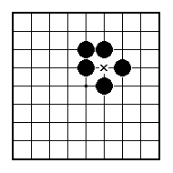
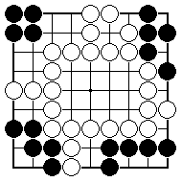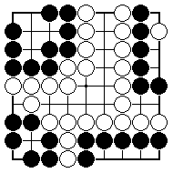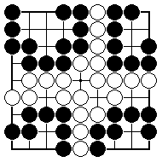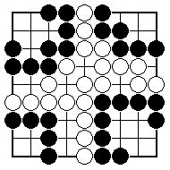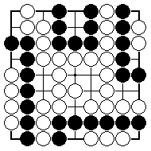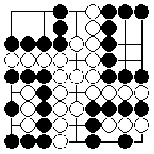
There are four black groups. Which are alive, dead, unsettled?

There are four black groups. Which are alive, dead, unsettled?
There are four black groups. Which are alive, dead, unsettled?

There are four black groups. Which are alive, dead, unsettled?

There are four black groups. Which are alive, dead, unsettled?

There are four black groups. Which are alive, dead, unsettled?

NAME:
BRITISH GO ASSOCIATION CERTIFICATE LEVEL 1 - SHEET 11

SHAPES FOR MAKING TWO EYES

